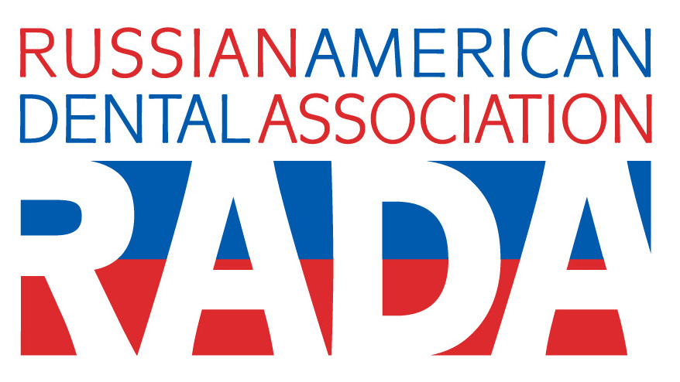
As part of our Oral Health Awareness Project

Russian-American Dental Association will be conducting

Free dental exam for children &
Free oral cancer screening for adults of all ages

For more information, please, contact us at 1-866-RADA DDS
(1-866-723-2337) or
Visit our website: www.radaonline.com

Co-sponsor – Russian-American Medical Association

